Unity Bootcamp - Creating a 2D Game

Part 5 - Better platforms

# 

# Better Edges

So the platforms we added earlier aren’t that great, the character gets stuck on them when you approach them from the side. Import the ***Advanced Platform*** package. Navigate to *Prefabs* and drag in this new platform.

The only difference with this prefab, is that it has two children, both called *Slider*. These are Game Objects that sit either side of the platform and have *Box Collider 2D* components with a *Slippery* physics material. This means that when the player collides with them the character won’t stick.



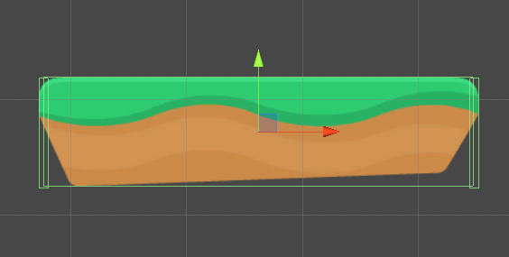

See the other box collider 2Ds (either side of the platform) and their green outlines.

# Moving platforms or spikes

Import the ***Move*** script into the game and attach it to something you want move.

Tweak the values in the *Move* component, the *Move To* value is where it will move to in relation to its origin. The *Move Speed* is how long it’ll take to get there, and the *Wait Time* is how long it’ll wait before moving back.

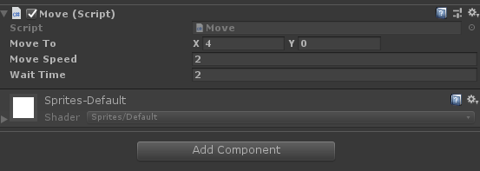

Rename this GameObject to Moving platform or Moving Spikes, then turn it into its own prefab.